Aircoach Announce Charity Partnership with St. Michael’s House
‘Keep St. Michael’s House Motoring!’

Press Release
Aircoach, Ireland’s leading private bus and coach operator has announced details of its new charity partnership with St. Michael’s House. The partnership which will extend over a period of two years aims to Keep St. Michaels House Motoring. The goal is to raise enough funds to buy a new minibus for St. Michaels House.
St. Michael’s House provides a comprehensive range of services and supports to men, women, and children with intellectual disabilities and their families. With 170 locations in the greater Dublin Area, the service supports approximately 1,782 people, providing a great impact for thousands of family members. While St. Michaels House is funded by the Health Service Executive it requires fundraising to supplement its range of supports for residential and Independent living.
Commenting on the announcement of their charity partnership with St. Michael’s House, Dervla McKay, Managing Director of Aircoach said; “We are delighted to have St. Michael’s House on board as our charity partner for the next two years. We admire the exceptional work they do for people with intellectual disabilities and we aim to fully support St. Michael’s House with their fundraising campaigns along with the provision of transport where required. We are looking forward to this partnership and hope that we can make a really positive impact on the services that St. Michael’s House provide.”
Speaking on Aircoach becoming their charity partner for the next two years, Barbara Wiseman, Head of Communications and Fundraising St. Michael’s House, said; “We are delighted to partner with Aircoach as their two - year commitment gives my colleague Jacqui McDonnell great scope to plan and engage in fundraising activities which provide support for our services. Education and awareness regarding our services is very important to us as well as much needed funds and we very much look forward to working together over the next two years".
As part of its partnership with St. Michael’s House, Aircoach will provide consistent fundraising support to the charity as well as participating in the Corporate Volunteer Programme where staff will complete a meaningful project and become more knowledgeable about St. Michael's House services. The aim is to raise enough money to allow St. Michaels House to buy a new minibus and keep the service users mobile. Aircoach will get involved in St. Michael’s House Bring a Book, Buy a Book annual national fundraising campaign which encourages people to host a Bring a Book, Buy a Book event in their place of work, school or college in order to raise funds for the charity. In 2018, 90,000 books were exchanged, raising over €30,000 for people with intellectual disabilities
ENDS

For more information, please contact
Michelle Lynch Fuzion Communications michelle@fuzion.ie +353 86 832 911

About Aircoach
Aircoach provides a range of high frequency, quality scheduled coach services to and from Cork and Belfast cities to Dublin City Centre and Dublin Airport. It is the only bus company in Ireland providing a 24- hour service. The company operates five key services connecting Dublin Airport with Dublin City Centre and its suburbs, as well as non-stop express services connecting Dublin Airport with both Cork and Belfast. Aircoach employs 250 staff and have a total fleet of 67 buses and coaches.
About St. Michael’s House
St. Michael’s House provides a comprehensive range of services and supports to men, women, and children with intellectual disabilities and their families in 170 locations in the greater Dublin Area. It supports 1,782 people and this has an impact on thousands of family members. St. Michael’s House is a company funded by the Health Service Executive (HSE) and the Department of Education and Skills. (Figures from 1st Jan 2019)
St. Michael’s House supports include;
- Residential supports and Independent living
- Clinical supports
- Day supports
- Schools
- Respite supports and
- Vocational training services.
St. Michael’s House is committed to delivering services and supports based on the needs, wishes and choices of people with an intellectual disability, based in that communities and connected to natural support networks.
For further information or to donate to St. Michael’s House please visit https://www.smh.ie/donate/

Photos
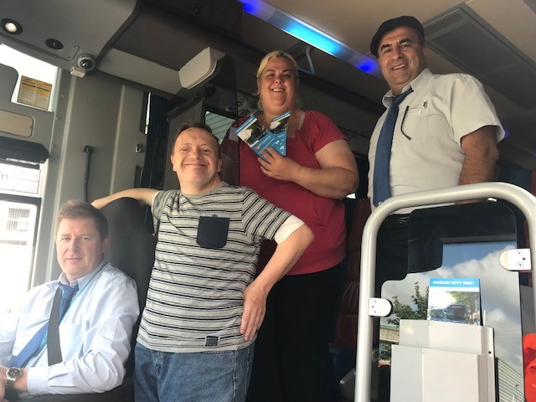
Paul Byrne (Aircoach), Sean Quinn (SMH), Claire Carrick (SMH) and Mohammed Mohammed (Aircoach)

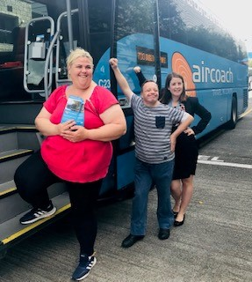
Claire Carrick (SMH), Sean Quinn (SMH) and Dervla McKay (Aircoach)

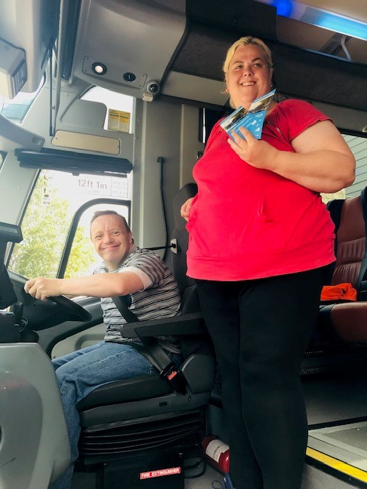
Seam Quinn (SMH) and Claire Carrick (SMH)

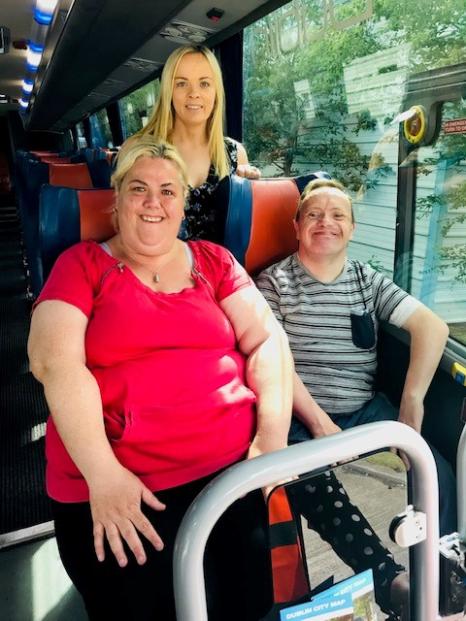
Claire Carrick (SMH), Sean Quinn (SMH) and Orla Helly (SMH)

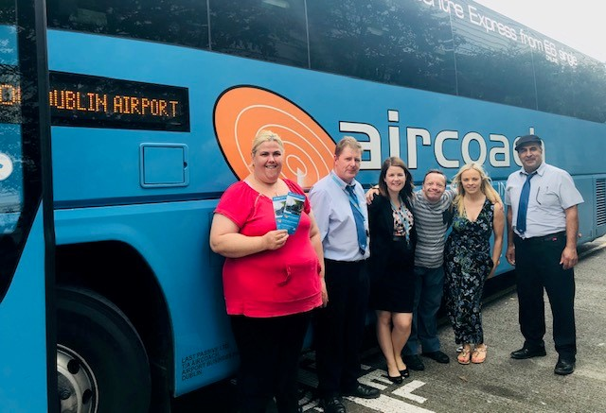
SMH and Aircoach

